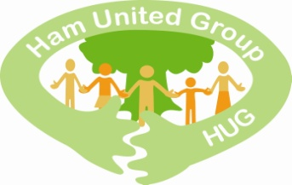

Annual General Meeting of the Ham United Group
Virtual meeting 25/11/2020
AGENDA

- Welcome and apologies

- Approval of the minutes of the 2019 AGM held on 28 November 2019

- Report by the Treasurer and approval of the accounts for the year ending 30 April 2020

- CIC report for the year ending 30 April 2020

- Report on our groups and activities during 2020: Richmond MakerLabs, FoHL, meditation, library garden and allotment, Ham Close, Green Screen.

- Update from the membership secretary

- Update on communications (newsletter, website, facebook, twitter)

- Plans for and meetings in 2021
New projects: Good Gardens for Everyone, bench on Ham Lands by the river

- Election of Directors and Officers
Please see summary sheet Directors and Officers

- AOB

Notes to agenda
- Applications for Directors or other officer posts please email us
- Voting will be by a show of hands
- Please fill in the proxy form if you are unable to attend
- HUG members only are eligible to vote – if you aren’t a member yet but would like to vote, please contact us asap.

Papers circulated with this agenda:
- Minutes of AGM 28.11.19
- Financial report for year ending 30.4.20
- CIC Annual Report for year ending 30.4.20
- Summary Ham Close development
- Summary of Directors and Officers, setting out rotation of retirement and proposed new Directors

